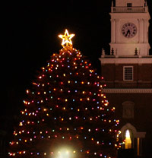

6:00 - 2012 Boston Magazine Design Home

7:00 Open
Call to Order
7:30 Citizen Comments

7:35 IT Assessment-Final Report, School Department and Advisory Board

Approval of Minutes
Appointments
Local Historic District Study Committee Interviews
Kim Zayotti
Jon Bond
Steven Hull
Katherine Kardok
Donna Fitzgerald

Old Business
- Police Station

New Business
- Budget

Upcoming Meetings

Announcements-Holiday Tree Lighting, Town Common December 4, 2011
Adjournment
Executive Session

